**The New Balance Falmouth Road Race**

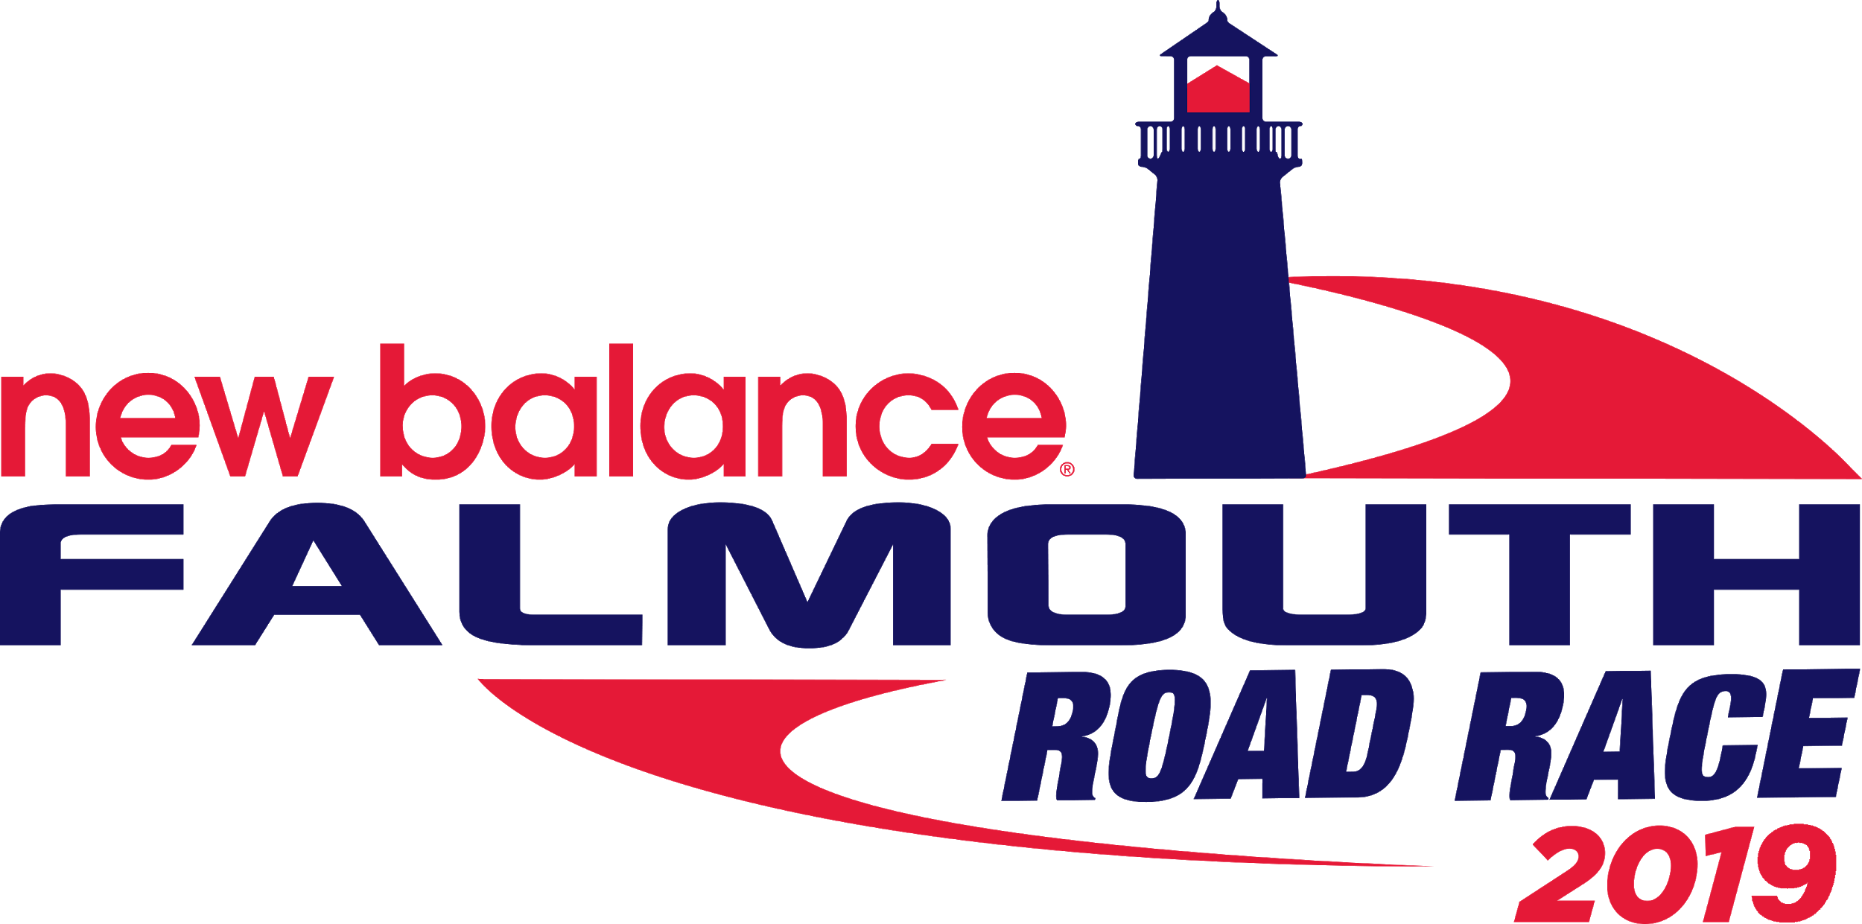

**2019 Economic Impact Report**

**Conducted as part of a Brandeis International Business School Field Project Course.**

**Supervised by:**

[**Dan Bergstresser**](mailto:dberg@brandeis.edu)**, Associate Professor of Finance, Chair of the Undergraduate Business Program**

[**Kristina Heavey**](mailto:kristinaheavey@brandeis.edu)**, Associate Director, Academic Experiential Programs**

**Students:**

**Xiao Yang, MA 2020**

**Guangji Ye, MSBA 2019**

**Jiawei Zhang, MA 2019**

**This material is based upon work supported by Brandeis University- International Business School for a course. Any opinions, findings, conclusions, or recommendations are those of the authors and do not reflect the views of Brandeis International Business School, its employees, or its administration.**

**Executive Summary**

The following report is designed to measure the economic impact of the New Balance Falmouth Road Race (FRR) on the town of Falmouth, Massachusetts in 2019.

As part of the work, the Brandeis team analyzed the runner demographics and developed an Economic Impact Model using Excel that is easy to use and update. This flexibility will enable the FRR team to change assumptions that will update and provide a new estimate for the race’s economic impact (direct and indirect expenditure in dollar amount).

The core thought behind the model is that there is different consumer behavior (average spending) within each demographic group, including location and age. Runners are assigned into three groups based on location: resident, which is defined as within 10-mile radius of Falmouth, non-resident staying in Falmouth, and non-resident not staying in Falmouth. Average spending is estimated based on government reports and historical data. The output of model includes economic impact, jobs created by the race, and state/local tax revenue.

|  |  |
| --- | --- |
| **2019 Falmouth Road Race Economic Impact** | |
| Overall Economic Impact | $16,557,100 |
| Local Job Creation | 108 |
| Direct State Tax Revenue | $471,563 |
| Direct Local Tax Revenue | $649,709 |

These numbers reflect the number of runners registered for the race in 2019. The number of runners might actually be slightly higher because there is difficulty in counting the number of runners who participate in the race but do not officially register. The model can make this adjustment automatically.

The team compared the final numbers with the research conducted by Babson College in 2003. After adjusting for inflation rate, the direct expenditure measured in 2019 is 50.77% higher than that in 2003.

Beyond direct money expenditure, FFR also contributes significant benefits to the local community and the Commonwealth of Massachusetts. In 2019, FRR’s charity teams raised a record $5.1 million to raise awareness for non-profits and charities around the state. FRR continuously commits to support the sustainable development of the local community and has donated more than $2.5 million since 2002.

The report concludes with suggestions that will further optimize the research, including conducting a survey to collect information that can be input into the model, counting the spectators more accurately, and establishing a database to store all historical data.

1. **Introduction**

The 2019 Falmouth Road Race is a tremendous event that enriches the regional lives of residents on the Cape and draws national attention to the town of Falmouth. The 2019 Road Race attracted 12,800 runners for this great event and an estimated 75,000 spectators lined Falmouth’s neighborhoods to cheer on the runners.

While the heart of the action takes place on Sunday, the festivities kick off on Thursday with a Health and Fitness Expo. This year, the Expo welcomed 20,000 people including 12,800 race participants, friends, family, and the general public to share in a three-day celebration featuring the latest in running, fitness, and uniquely Cape Cod items.

The Falmouth Road Race is a 7-mile race that takes place on the Sunday of race weekend. It has an elite men, women, and wheelchair division, in addition to individual and charity runners.

Based on the estimation conducted by the team, the Falmouth Road Race increased Falmouth’s business volume by $16.56 million.This year’s race had a direct impact on the local economy totaling $10.48 million. The re-spending of these dollars generated an additional $6 million in the local economy (indirect impact). The race also generated an estimated $1.12 million in government tax revenues for the local and state governments.

1. **Demographics**

At the state level, slightly more than 85% of the road race runners are MA residents. Another 3.1% of runners traveled from New York; 2.4% from Connecticut, 1.3% from New Hampshire, and 1% from New Jersey. Even more impressive, runners from the UK, Kenya, Germany, Columbia and Spain participate in the world-renowned Falmouth Road Race.

Figure 1: Number of runners over US

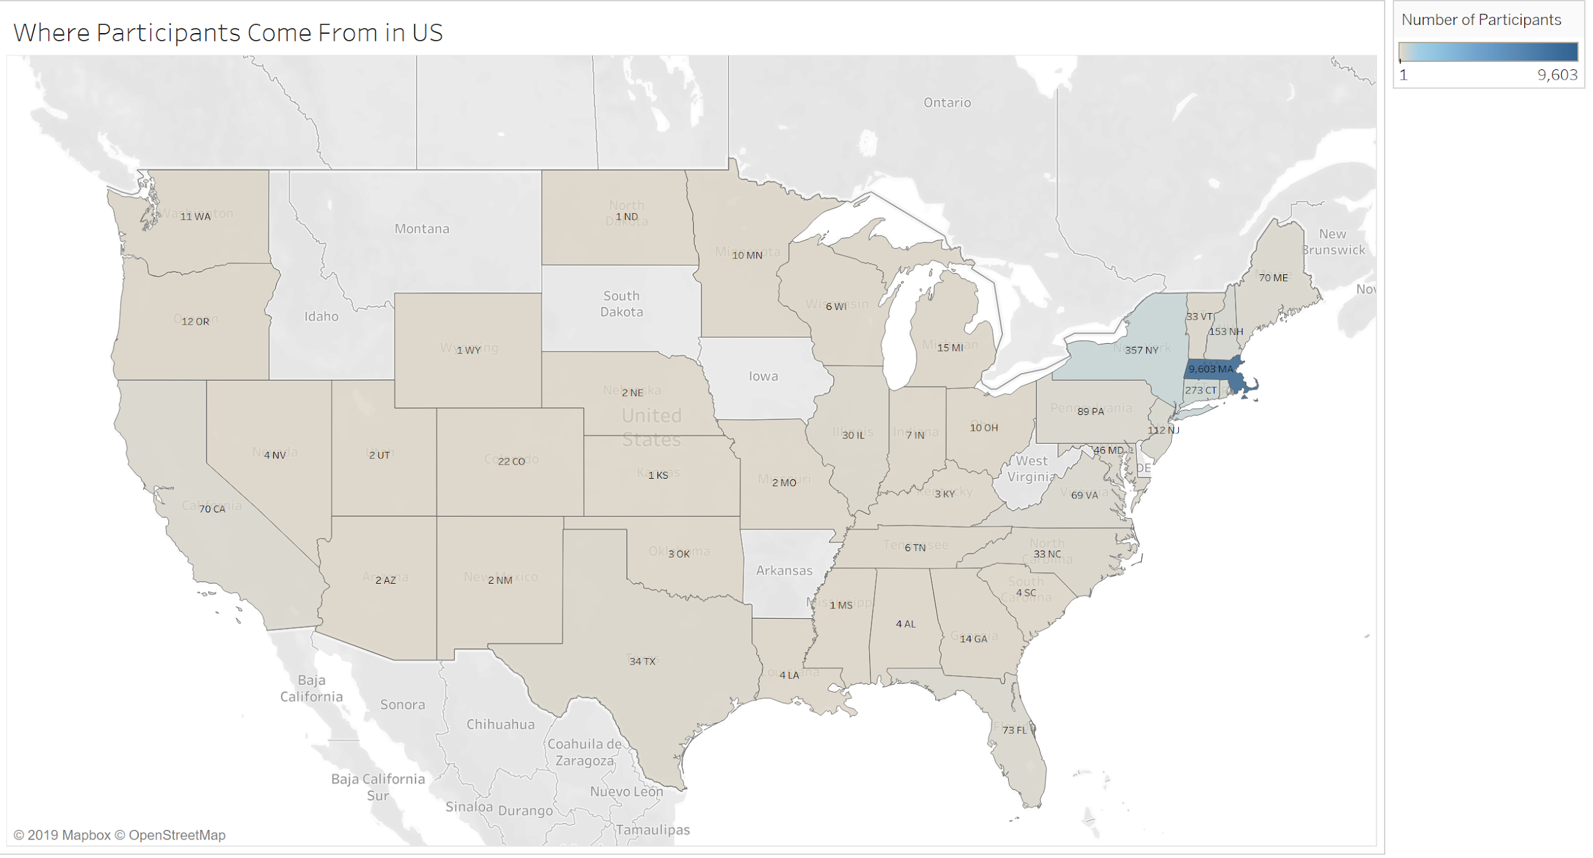

Figure 2: Number of runners worldwide

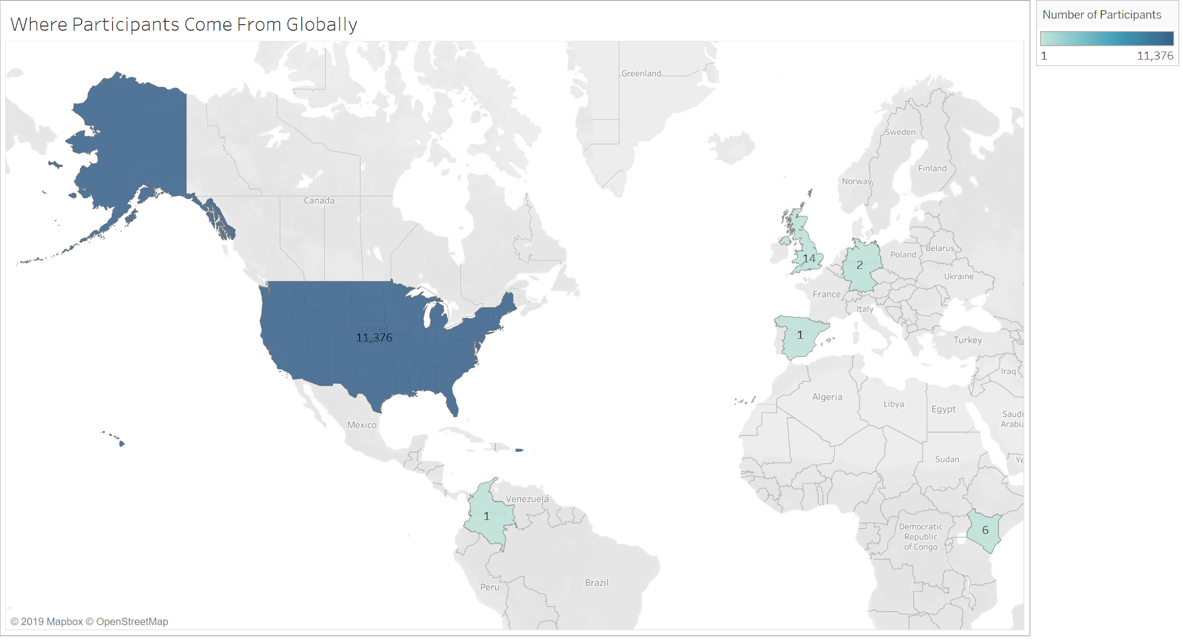

Figure 3 is a heat map that shows the number of runners from local Massachusetts cities/towns. 20% of the runners came from the Boston area and Falmouth.

Figure 3: Number of users heatmap

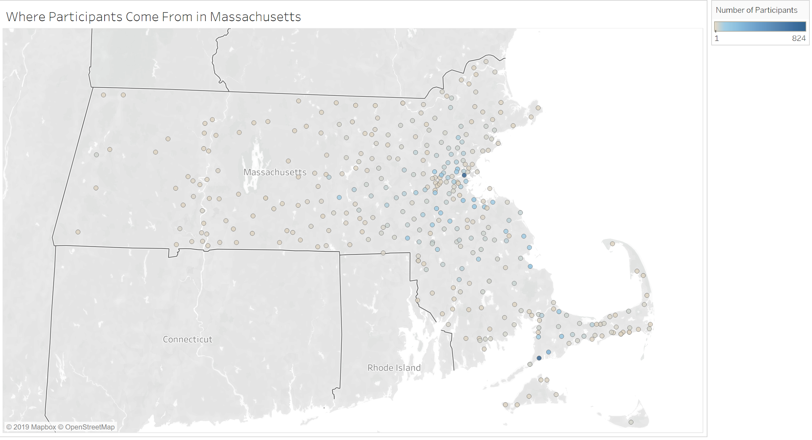

The runner population consists of 56% females and 44% males. The race attracts more female runner across all age groups with the exception of the “above 60” group. Age group 25-34 and 35-44 has the most runners, accounting for 27% and 21% of the total number of runners.

Figure 4: Runners age and gender distribution

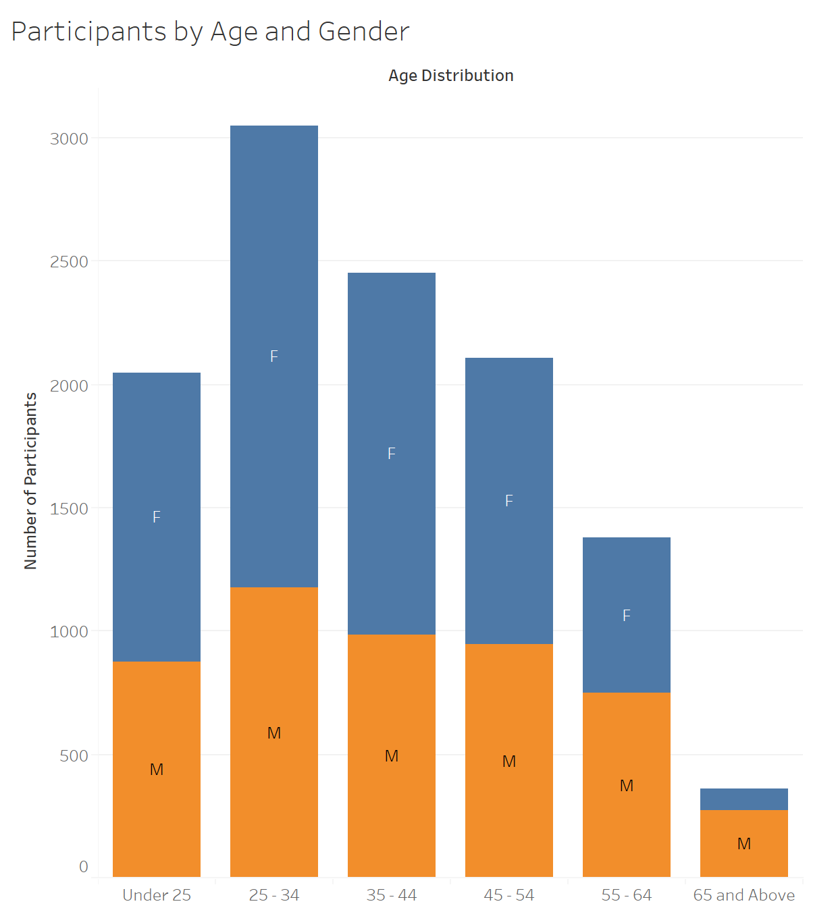

1. **Model Description**

The Brandeis team developed an Excel model to help the Falmouth Road Race estimate the economic impact of the race on the community in the dollar amount. The model is designed to be user-friendly and can be updated yearly once additional data is available. The economic impact is calculated by summing the direct expenditure and indirect expenditure. Direct expenditure represents the money spent in Falmouth directly by race participants, including runners and spectators. Indirect expenditure is the economic value created by the respending of the money received from direct expenditure, which is calculated from multiplying direct expenditure by spending multiplier.

The core thought behind the model is that all runners are assigned into three groups: Falmouth resident runner, non-resident runner staying in Falmouth, and non-resident runner not staying in Falmouth. Falmouth residents are defined as runners who live within a 10-mile radius from Falmouth. This includes the cities of Falmouth, Mashpee, Bourne, Sandwich, and the island towns of Martha’s Vineyard and Oak Bluffs. These three groups have different consumption behaviors and contribute a different level of economic impact.

Within each runner age group, the average expenditure is adjusted by age group as different age ranges tend to have various expenditure capacity. The model also estimates the number of spectators and the expenditure spent by them. The model then sums the direct expenditure together and generates economic impact results.

The model contains three tabs: Assumptions, Adjustments, and Model Outputs. Users can modify or adjust numbers in cells with the yellow background, and the model will simulate the relative results automatically.

* The Assumptions tab requires inputs including *average expenditure per runner* and *spectators brought by each runner* for each of the runner groups. Users also need to input key economic impact ratios, such as *Spending Multiplier*, *expenditure per job created*, and *expenditure to tax revenue ratio*.
* The Adjustment tab allows users to adjust the value of expenditure based on age and runner group. Users can make adjustments to all inputs and assumptions used in the model.
* The Model Outputs tab shows the process to calculate the economic impact step by step. The Output tab also shows the economic impact measured in the dollar amount, which is the sum of direct and indirect expenditure, jobs created by the race, and tax revenue for both state and local government.

1. **Model Simulations**

The Brandeis team conducted research on tourism reports issued by both state and federal government agencies and collected economic reports from other road races. The demographic data of the runners is from mtecresults.com, a company used for official runner times and posts results online. The model then calculates the number of runners in each residential group and age group using an Excel pivot table. The team makes some assumptions and adjustments based on the following sources:

* According to the Economic Impact of Travelers on Massachusetts (CY2018) issued by the Massachusetts Office of Travel & Tourism, every $153,066 spent in Massachusetts by travelers generated one job in 2017. Expenditure has a total output multiplier of 1.57. On average, every dollar spent by travelers produced $0.23 in payroll income for Massachusetts’ residents during 2017. And on average, every dollar spent by travelers produced $0.045 in state tax revenue and $0.062 in local tax revenue.
* Based on the data from the Falmouth Road Race website, there are around 75,000 spectators. We assume that on average, each runner brings 5.86 spectators and spectators have the same demographic distribution as runners.
* The adjustment on travel expenses of different ages is based on data from the Bureau of Labor Statistics. If people aged 35-44 is set as the baseline for the travel expenditure, the age range under 25 spends 57% less, age range 25 – 32 spends 22% less, age range 45 – 54 spends 6% more, age range 55 – 64 spends 5% more, and age range 65 and over spends 11% more.

Three methods can be adapted to estimate the average expenditure of each residential group:

Method 1: Average travel expenditure can be collected from the government agencies.

* The team assumes non-resident participants staying in Falmouth have similar spending levels as normal travelers to the Falmouth Area during the summertime. Average travel expenditure of non-resident participants staying in Falmouth is $202.85, which is calculated by using total annual tourism income in Cape Cod ($1060.9 million from Massachusetts Office of Travel & Tourism), divided by the total number of visitors to Cape Cod (5.23 million from Cape Cod Commission).
* The impact contributed by resident participants and non-resident participants not staying in Falmouth is assumed to equal their one-day living expenditure in the Cape Code area, which is equal to $82.05 per day (Economic Policy Institute Family Budget Calculator).

Method 2: Average travel expenditure can be based on historical surveys.

* The team realized that the average expenditure used in the economic impact report written by Babson College 16 years ago is significantly higher than the value used in Method 1. This may be because the participants reported the expenditure of the total group rather than each person individually. However, the team believed the expenditure data collected 16 years ago can still be useful for estimation and comparison. According to the survey in 2003, the average expenditure per resident participant is $396.38, average expenditure per non-resident participants staying in Falmouth $847.14, and average expenditure per non-resident participant not staying in Falmouth is $170.36. These spending number should be further adjusted to include inflation, which is 139%. (Bureau of Labor Statistics, CPI Inflation Calculator)

Method 3: The team recommends that the Falmouth Road Race Team conduct a spending survey after the race in the future or adds additional questions to their registration page. The data that could be collected from the survey would be more representative and time-efficient. The team provides a sample survey in the Appendix section of the report for future reference.

1. **Economic Impact Analysis**

**5.1 Money Impact**

Based on the results of the Method 1 calculation, which used data collected from government agencies, the team reveals some direct money impacts the road race brought to local community:

* 89.38% runners-participants traveled at least 10 miles to participate in the race. Among these non-resident runners, 85% live in Massachusetts and the remaining 4.38% are from across the United State and around the world, including the United Kingdom, Kenya, Germany, and Columbia.
* Total estimated direct expenditure is $9,749,432 and the indirect expenditure is $5,654,671. Thus, the overall economic impact for New Balance Falmouth Road Race is estimated at $15,404,103.
* Local income impact of the Falmouth Road Race on the region is equivalent to creating 101 local jobs.
* Local income impact of the Falmouth Road Race is estimated to bring total $438,724 direct state tax revenue and $604,465 direct local tax revenue.
* The team identifies the results from Method 1 as a conservative estimation.

The team conducted this calculation using the number of runners registered and whose times were reported on the mtec website. Based on feedback from the Falmouth Road Race team, the actual number of runners should be slightly higher. There is difficulty in counting the number of runners who participate in the race because not all officially register.

|  |  |  |
| --- | --- | --- |
| **2019 Falmouth Economic Impact-Model 1** | | |
|  | Using number of runners who registered and finished | Using 10% to account for runners that do not register |
| Direct expenditure | $9,749,432 | $10,479,177 |
| Indirect expenditure | $5,654,671 | $6,077,923 |
| Number of jobs created | 101 | 108 |
| Direct state tax revenue | $438,724 | $471,563 |
| Direct local tax | $604,465 | $649,709 |
| **Overall Economic Impact** | **$15,404,103** | **$16,557,100** |

The expenditure from the Method 2 is calculated from the survey data from the Babson report 16 years ago and adjusted by inflation. Method 2 number is more aggressive and noticeably higher than the expenditure from Method 1. The team feels the result from Method 2 is more optimistic.

|  |  |  |
| --- | --- | --- |
| **2019 Falmouth Economic Impact-Model 2** | | |
|  | Without 10% increase | With 10% increase in runners |
| Direct expenditure | $49,498,994 | $53,787,585 |
| Indirect expenditure | $28,709,417 | $31,196,799 |
| Number of jobs created | 511 | 555 |
| Direct state tax revenue | $2,227,455 | $2,420,441 |
| Direct local tax | $3,068,938 | $3,334,830 |
| **Overall Economic Impact** | **$78,208,411** | **$84,984,385** |

The team believes that the actual economic impact falls within the range between conservative estimation and optimistic estimation. As the team suspects the input data in Method 2 is exaggerated, the actual number is higher but close to the conservative estimation.

**5.2 Other Impacts**

Besides the money impact, Falmouth Road Race also contributes to the quality of life of the involved communities. This is mainly displayed through:

* Compared to other similar events, Falmouth Road Race has a large amount of sponsors. The majority of the sponsors are either local entities or an entity that has a strong tie to the community.
* Besides the road race, Falmouth Road Race also organizes several community outreaches events, including SBLI Family Fun Run, Health & Fitness Expo, Bike Valet Program, and Falmouth Walk Course. These fun events have been the catalyst for a number of local citizens’ change of lifestyle from sedentary to active.
* The race helps raise awareness for non-profits and charities. In 2019, Falmouth Road Race’s charity teams raised a record $5.1 million. There are over 100 nonprofit organizations participating, including AGC Scholarship Foundation, American Cancer Society, Cape Cod Community College Education Foundation, Cops for Kids with Cancer, etc.

Figure 5: Number of Charity Runners from 2014 to 2017

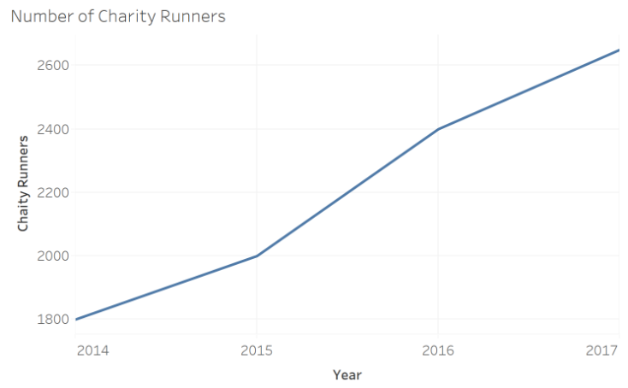

Figure 6: Number of Nonprofit Programs from 2014 and 2019

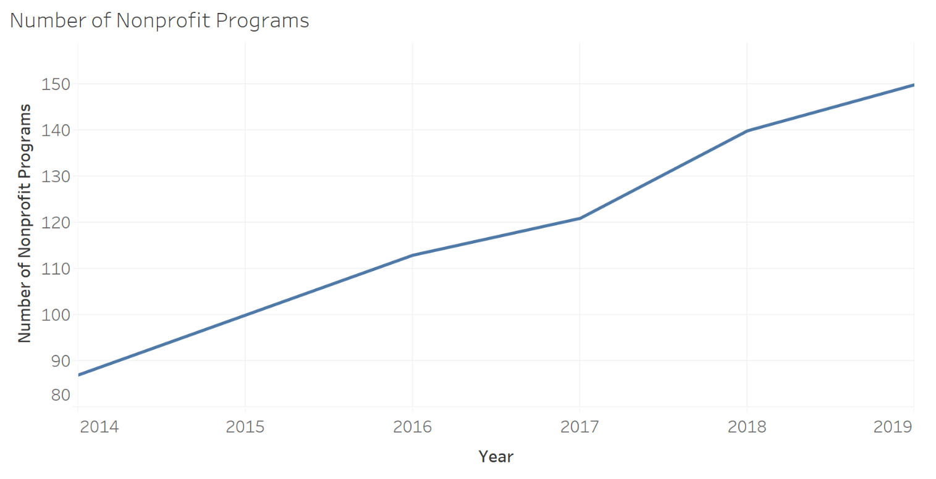

* Falmouth Road Race continuously commits to support the sustainable development of the Falmouth local community. Falmouth Road Race has donated more than $2.5 million to the local community since 2002. The race has established a scholarship program for graduating high school students who reside in Falmouth year-round and provide volunteer opportunities to local students to contribute to the community. Graduating seniors who will be attending college or trade school are eligible for one of at least ten available scholarships. Moreover, Falmouth Road Race also donates sports facilities to local athletic associations and hospitals to help raise health awareness of local residents.

Figure 7: Falmouth Road Race Donations to Local Organizations and Programs

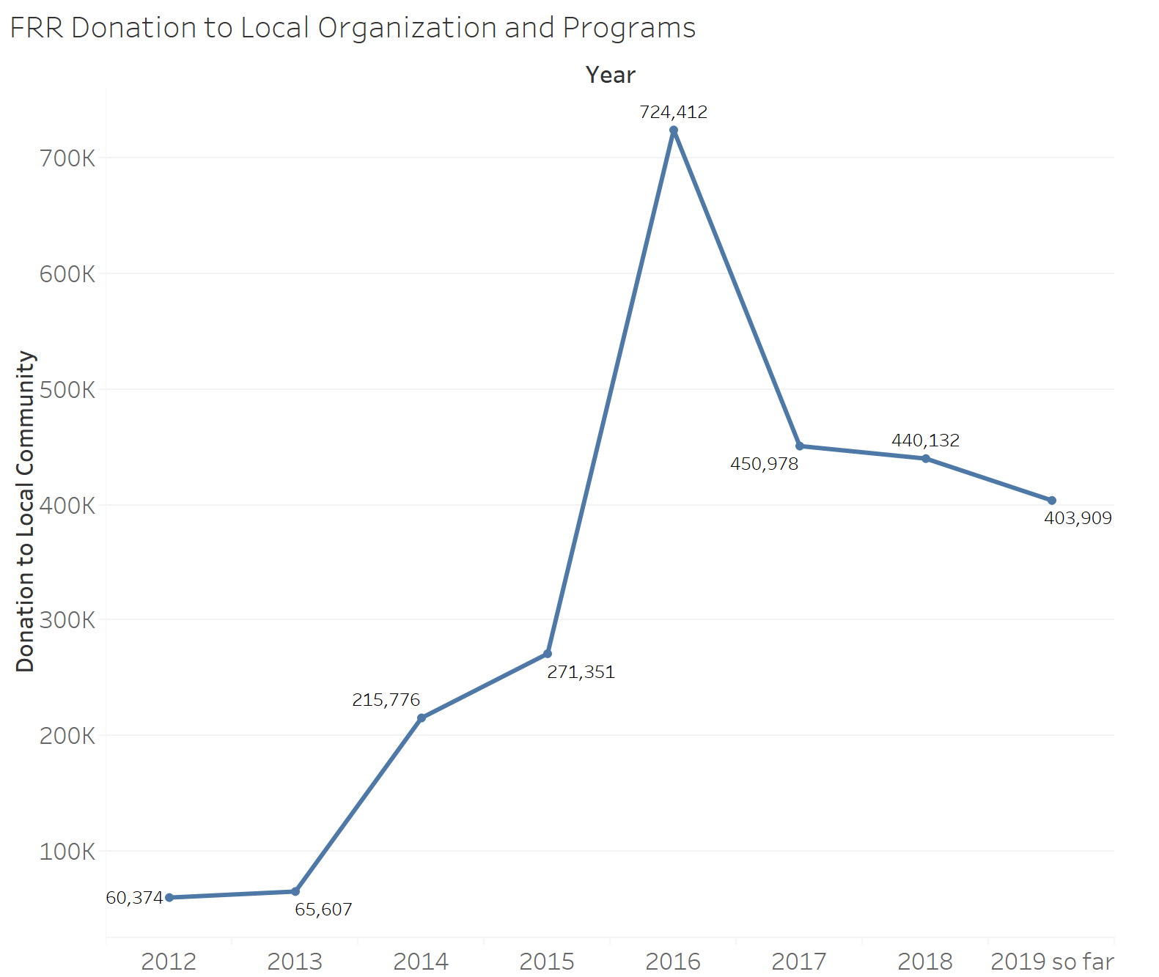

Falmouth Road Race also negatively impacts the local community, largely because the visitors to Falmouth during the race weekend is larger than the population of Falmouth. However, the team conducted research on traffic volume and believes the negative impact is not significant. Based on the traffic data provided by MassDOT, the team compared the traffic volume on the Bourne Bridge during the race weekend to normal summer weekends. The traffic volume only increased significantly on the race day morning, but the overall increase is not noticeable, indicating the negative impact brought by traffic to the community is not as significant as some might think.

Figure 8: Bourne Bridge Hourly Traffic Volume-Race Day Sunday   
Comparing the Sunday before the race, Race Day Sunday, and the Sunday after the race

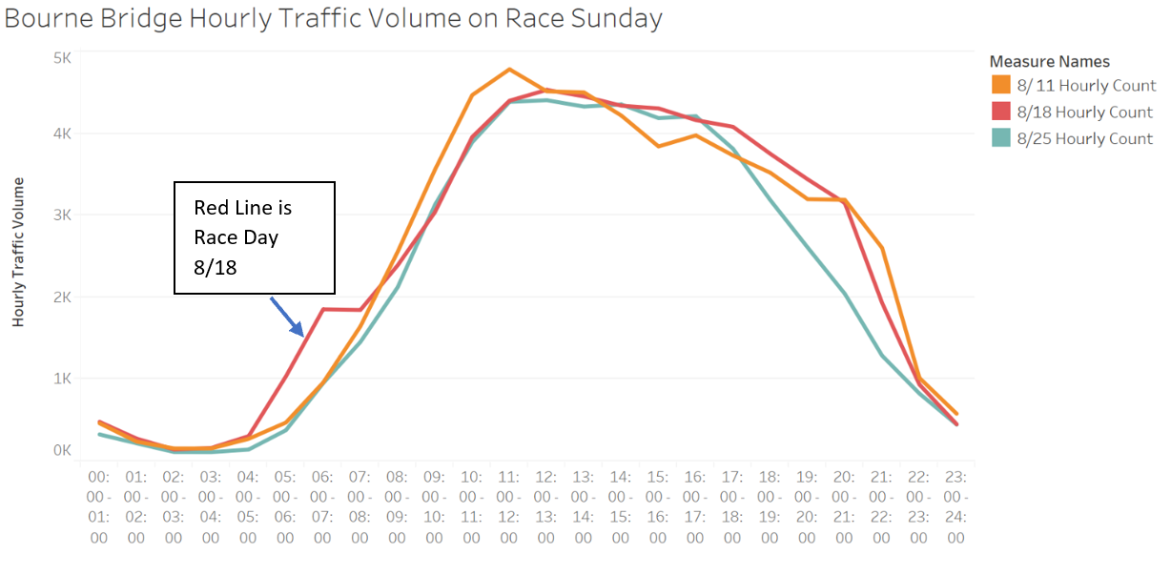

Figure 9: Bourne Bridge Hourly Traffic Volume- Race Week Saturday

Comparing the Saturday before the race, Race Day Saturday, and the Saturday after the race

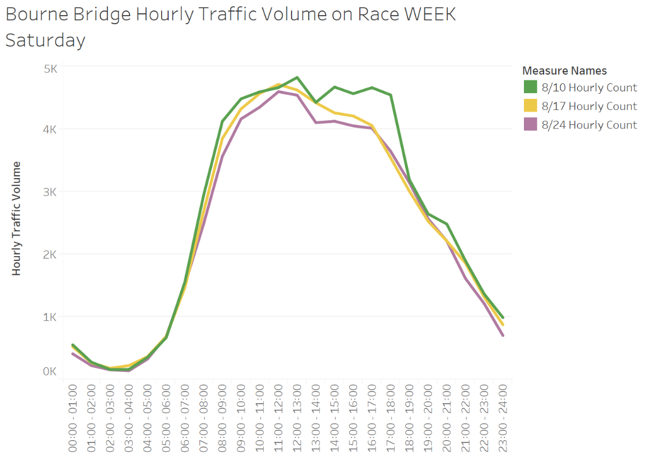

**5.3 Compare with Other Events**

The Brandeis Team compared the outcome of this report with the research conducted by Babson College in 2003. The report written by Babson College in 2003 only includes direct expenditure, so the team compares the direct expenditure in 2003 to the direct expenditure in 2019. After adjusted for inflation rate, the total economic impact brought by Falmouth Road Race was $6.95 million in 2003. Using the estimation from Method 1, direct expenditure increases by 50.77% in 16 years. However, as the team suspects the average expenditure per person from the survey is overestimated, the actual increase may be much higher. Using data from Method 2, the direct expenditure increases by 674%. However, the weakness of using data from Method 2 in comparison is that the team assumes that the average expenditure per person stays the same after adjustment for inflation. The percentage increase in direct expenditure tracks the percentage increase in number of runners and spectators. The team believes the comparison using the two methods is not accurate. Therefore, the team recommends Falmouth Road Race to conduct a spending survey next year to get more representative expenditure value.

The team also compared the Falmouth Road Race to other races. Harry Davakos, the Director of Sport Management Program at the Military College of South Carolina-The Citadel, conducted an economic impact study in 2007 on the Cooper River Bridge Run in the City of Charleston, South Carolina.

|  |  |  |  |
| --- | --- | --- | --- |
| **Comparing Falmouth Road Race to Other Races** | | | |
|  | **Falmouth Road Race (2019)** | **Cooper River Bridge Run (2004)** | **Wharf to Wharf** |
| Number of runners | 12,800 | 29,930 | 16,000 |
| Economic Impact | $15.4 million | $14.3 million | $8 million |
| Adjusting for inflation | $15.4 million | $19.81 million | $8 million |

In comparing the three races, the number for the Cooper River Run is a little higher than $15.4 million for Falmouth Road Race. However, the Cooper River Bridge Run is officially labeled as the 3rd largest 10k running event in the USA, and one of the largest worldwide. Despite the scale being much larger than Falmouth Road Race, you’ll notice that there is not a significant financial gap between the two races. Falmouth Road Race has a larger economic impact on the local community.

1. **Recommendations**

**6.1 Survey**

We strongly suggest that the Falmouth Team consider either asking participants to fill out a survey post-race, or to include a series of questions during the registration. The main goal is to collect information that can be input into the model to calculate the economic impact of the race on the Falmouth Community. In addition, the survey research is designed to measure overall event satisfaction(Q21), sponsorship awareness (Q22), and additional “tourist” activities (Q18) undertaken by all participants.

**6.2 How to count for spectators**

Method 1: Survey

1. To runners: figure out how many spectators each runner brings
2. On the race day, randomly interview spectators to find out what percentage of them are coming for a specific runner during the race (others might come and cheer for all runners)

Method 2: Use estimates

Use spectator/runner ratio calculated from other comparable races.

Method 3: Density analysis

Assume spectators with certain distribution (ex. evenly distributed along the course), we can figure out how areas are occupied. Then multiply the density to get the number. For example, we assume people are evenly distributed within 3 meters of 7 miles course, which is a rectangle with length 7 miles and width 3 meters. With density 1people/m2, the spectators’ number would be 33,600.

**6.3 Database**

We strongly suggest that the Falmouth Road Rce team implement a database to store all historical data including runners’ information, survey responses, other useful data (Expo vendor spending, Falmouth Road Race, Inc. spending, Google trends of keyword “Falmouth Road Race”, AirBnB prices during the week, local business sales, etc.). It will be useful in further analysis in terms of time trend.

**References**

Davakos, H. (2007). Economic Impact of 10K Race on the Greater Charleston, SC Area. *Economic Impact of 10K Race on the Greater Charleston, SC Area*, *10*(7). doi: 10.9737/hist.2018.658

*Massachusetts Office of Travel & Tourism 2017 Annual Report*. (n.d.). *Massachusetts Office of Travel & Tourism 2017 ANNUAL REPORT*.

*The Economic Impact Of Travel on Massachusetts Counties 2017*. (n.d.). *The Economic Impact Of Travel on Massachusetts Counties 2017*.

Economic Policy Institute Family Budget Calculator https://www.epi.org/resources/budget/).

Travel expenditures by age. (2003, November 4). Retrieved from <https://www.bls.gov/opub/ted/2003/nov/wk1/art02.htm?view_full>.

Wharf to Wharf Our Story. (n.d.). Retrieved from <https://wharftowharf.com/our-story/#tab-race_history>.

MASS DOT Transportation Data Management System. Retrieved from <https://mhd.ms2soft.com/tcds/tsearch.asp?loc=Mhd&mod=TCDS>.

Appendix A:

Sample Survey Questions

1. What’s your age?
   1. 10-20
   2. 20-30
   3. 30-40
   4. 40-50
   5. 50-60
   6. Over 60s
2. What’s your gender?
   1. Male
   2. Female
   3. Prefer not to disclose
3. Where are you from?
   1. Short Answer: State and city
4. How would you define yourself?
   1. Falmouth resident (Within 10 miles)
   2. Non-Falmouth resident staying in Falmouth overnight
   3. Non-Falmouth resident NOT staying in Falmouth overnight
5. What’s your household income?
   1. less than 25,000
   2. 25,001-50,000
   3. 50,001-75,000
   4. 75,001-100,000
   5. 100,001-150,000
   6. over 150001
6. How did you learn about the New Balance Falmouth Road Race?
   1. Newspaper
   2. Social Media
   3. TV/Broadcast
   4. Friends/Relatives
   5. Other
7. How many times have you attended the Falmouth Road Race?
   1. 0
   2. 1
   3. 2
   4. 3 or more
8. When you travel to Falmouth for the race, what mode of transportation do you use?
   1. Personal Vehicle
   2. Public transportation
   3. Ferry
   4. Uber/Lyft
   5. Other
9. How many nights did you stay in Falmouth?
   1. 0
   2. 1
   3. 2
   4. 3
   5. 4
   6. 5 days or more
10. Where did you stay?
    1. Hotel
    2. AirBnB
    3. With a relative or friend
    4. Campsite
    5. Other
11. How many people did you bring with you to the race?
    1. 1
    2. 2
    3. 3
    4. 4
    5. 5
    6. 6+
12. How much did you and your party spend on the following:
    1. Lodging (total)?
    2. Dining out?
    3. Retail?
    4. Groceries?
    5. Transportation?
    6. Other?
13. What do you like most about Falmouth?
14. Have you considered buying real estate in Falmouth?
    1. Already own
    2. Considering
    3. Never consider
15. Would you consider visiting Falmouth for purpose of traveling?
    1. Yes
    2. No
16. If yes, which season are you most likely to return to Falmouth?
    1. Spring
    2. Summer
    3. Autumn
    4. Winter
17. Which public services did you use during your stay in Falmouth (you can select more than 1)
    1. Local parks and beaches
    2. Local hospitals & emergency rooms
    3. Local police
    4. Local fire department
    5. Local transportation
    6. Local parking.
    7. Others
18. What other road races have you attended?
19. Do you have any recommendations for the Falmouth Road Race?
20. When you think of Falmouth Road Race sponsors, which companies or brands come to mind?